**Three Tier Architecture**

1.Create VPC

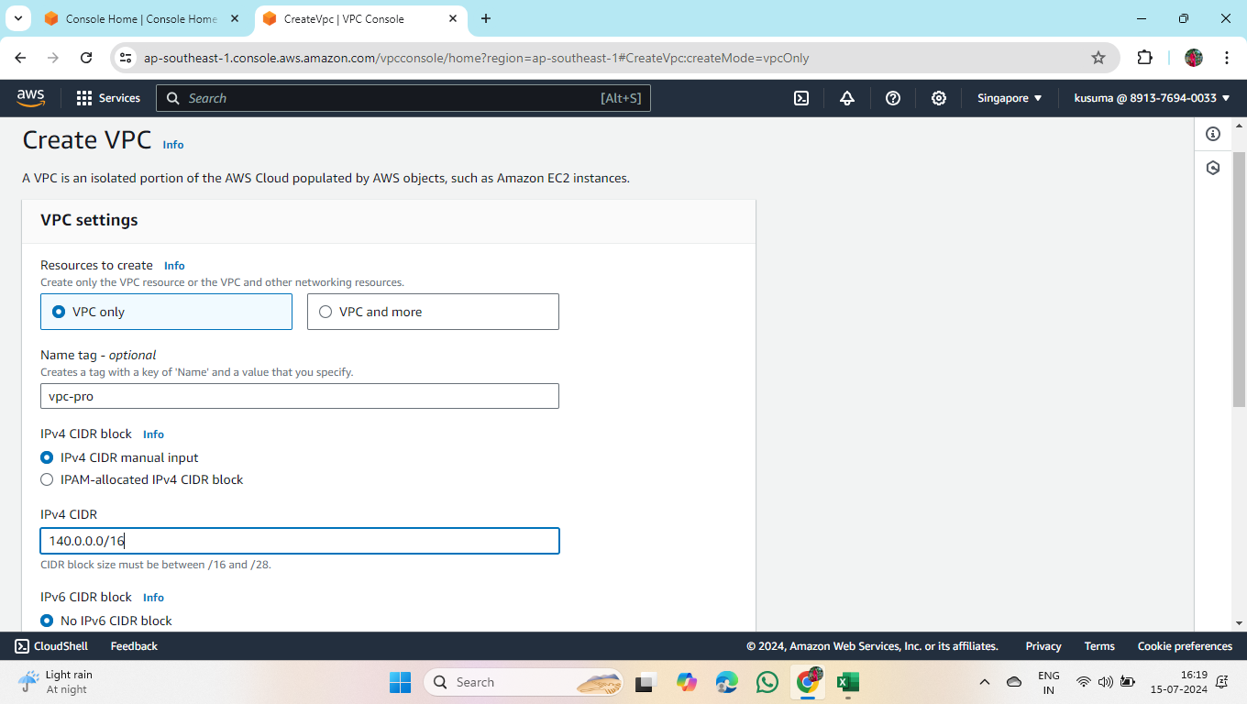

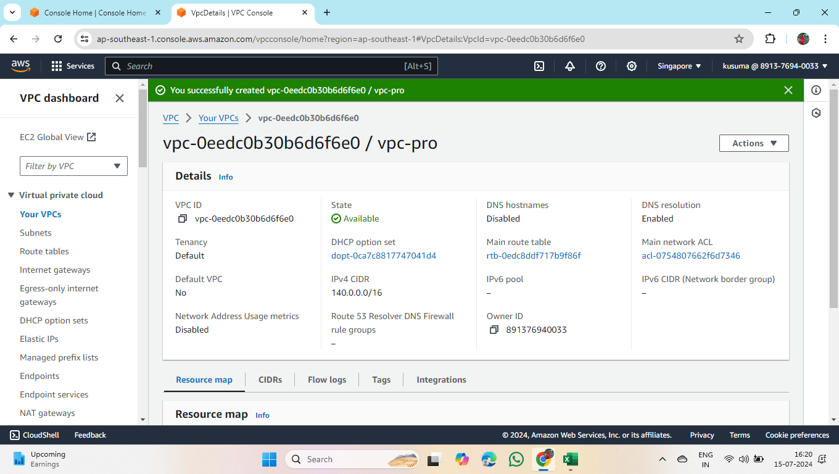

2.Create 2 public subnets and 4 private subnets in the availability zones.

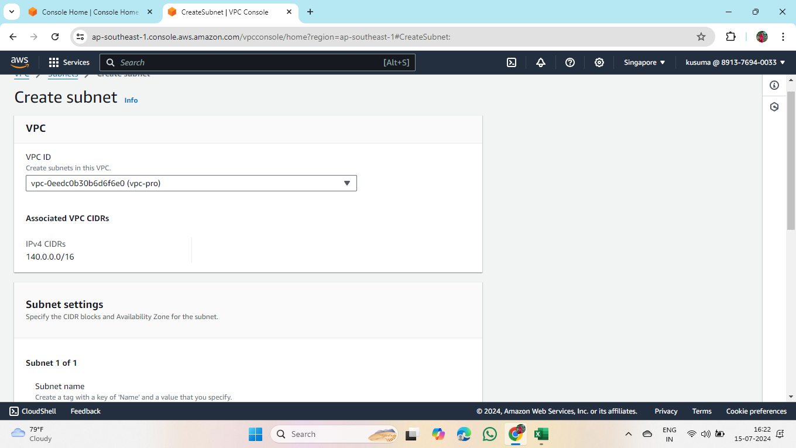

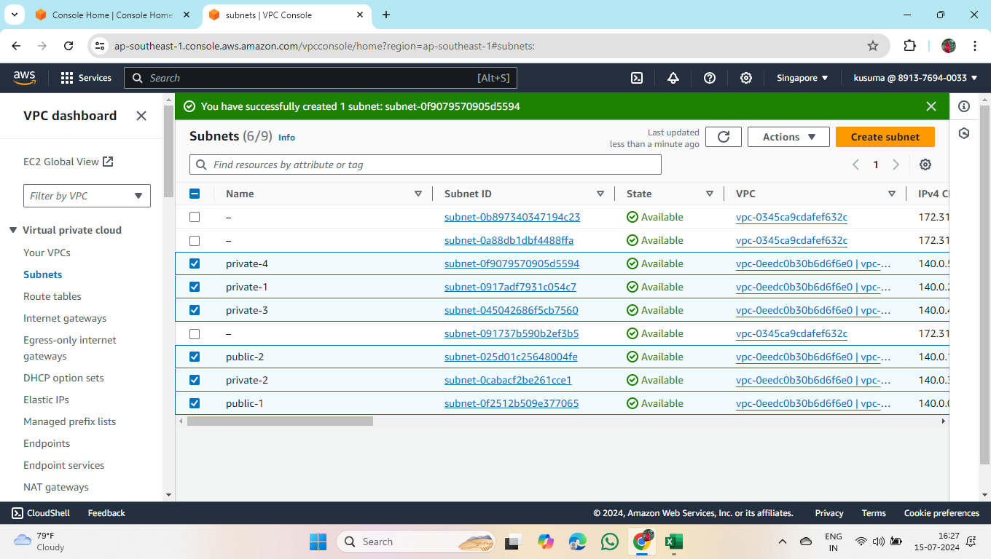

3.Create 6 route tables for respective 6 subnets.

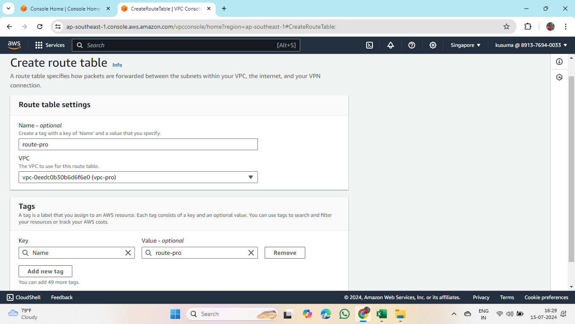

* Follow the same for remaining 5 route tables.

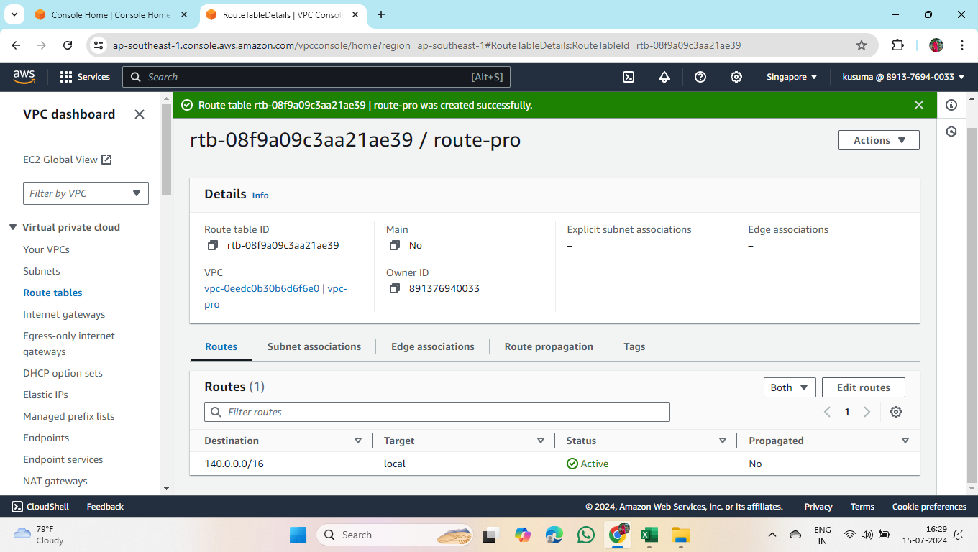

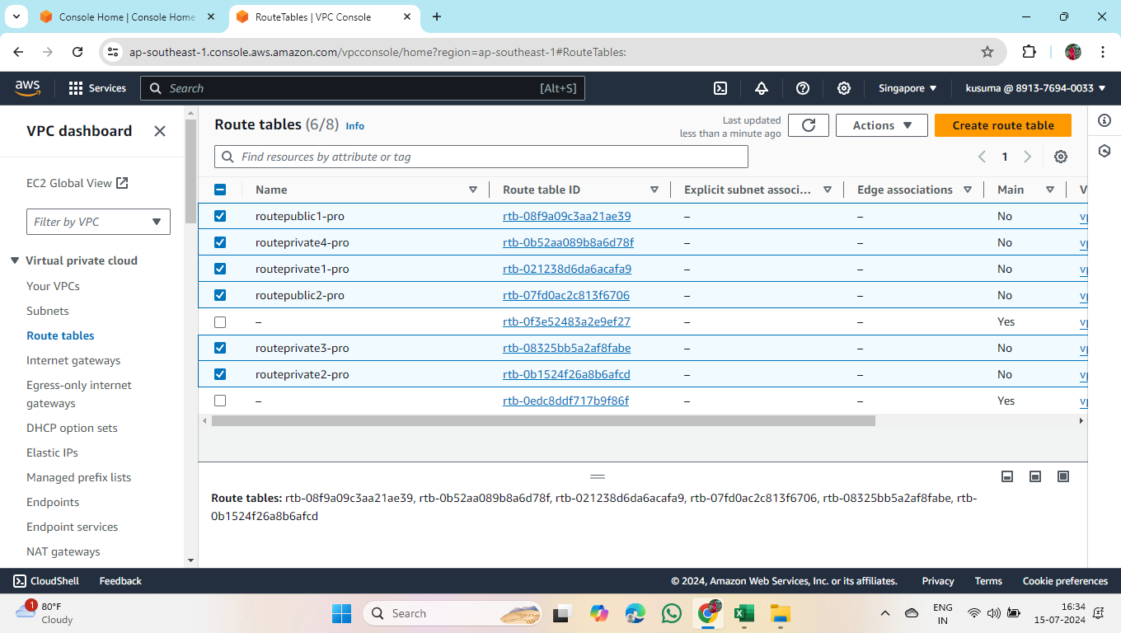

4.Select required route table to subnet and save associations in all the route tables.

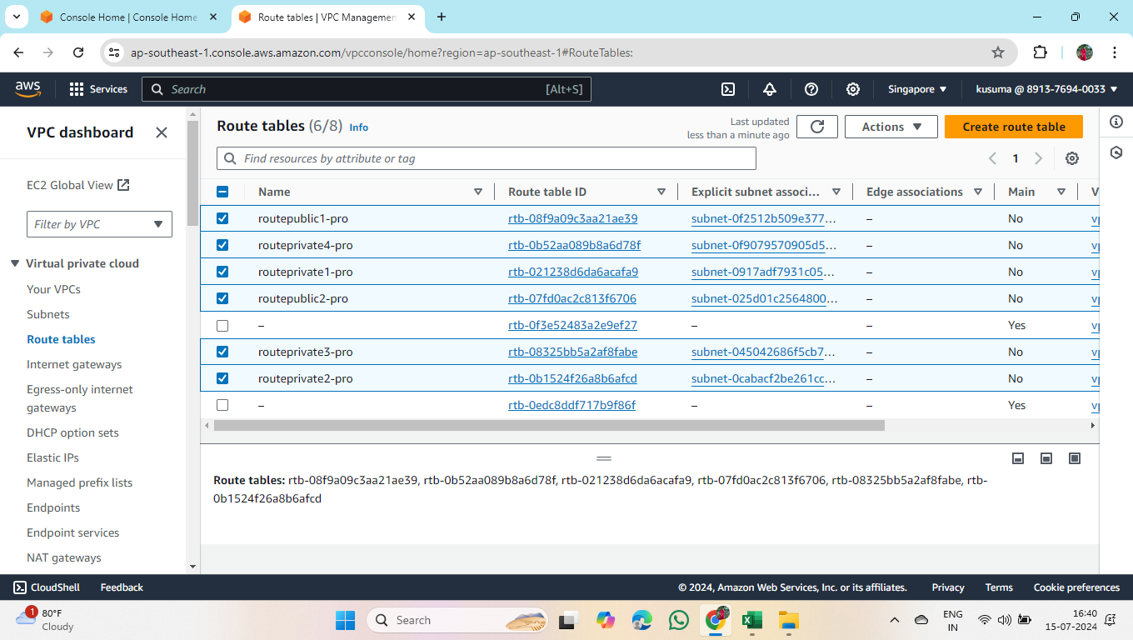

5.Create Internet Gateway and attach it to vpc.

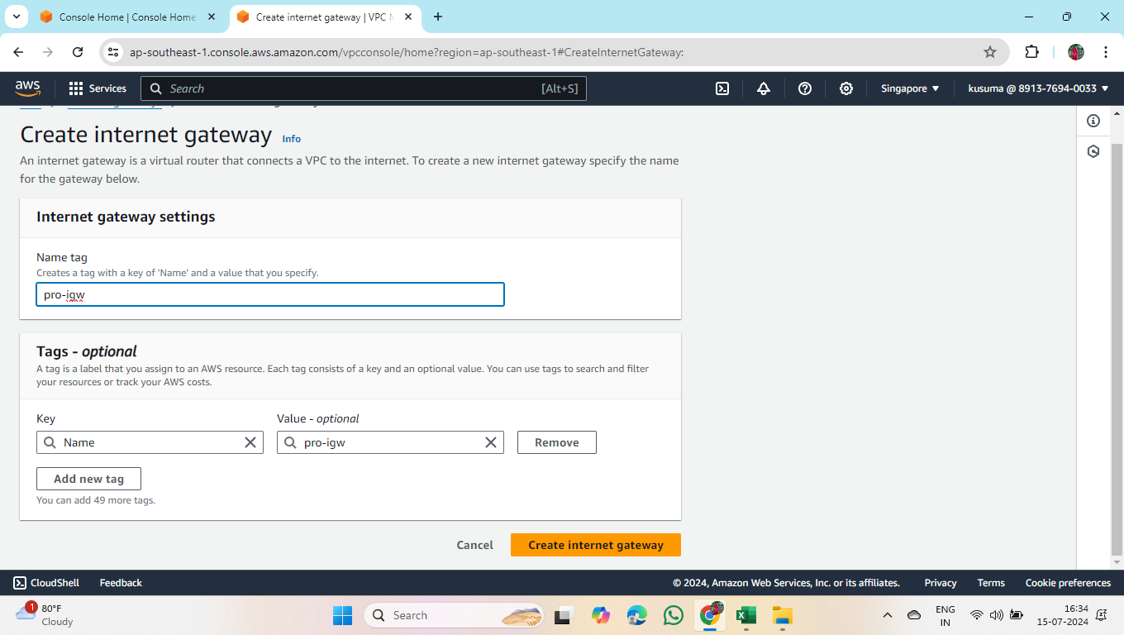

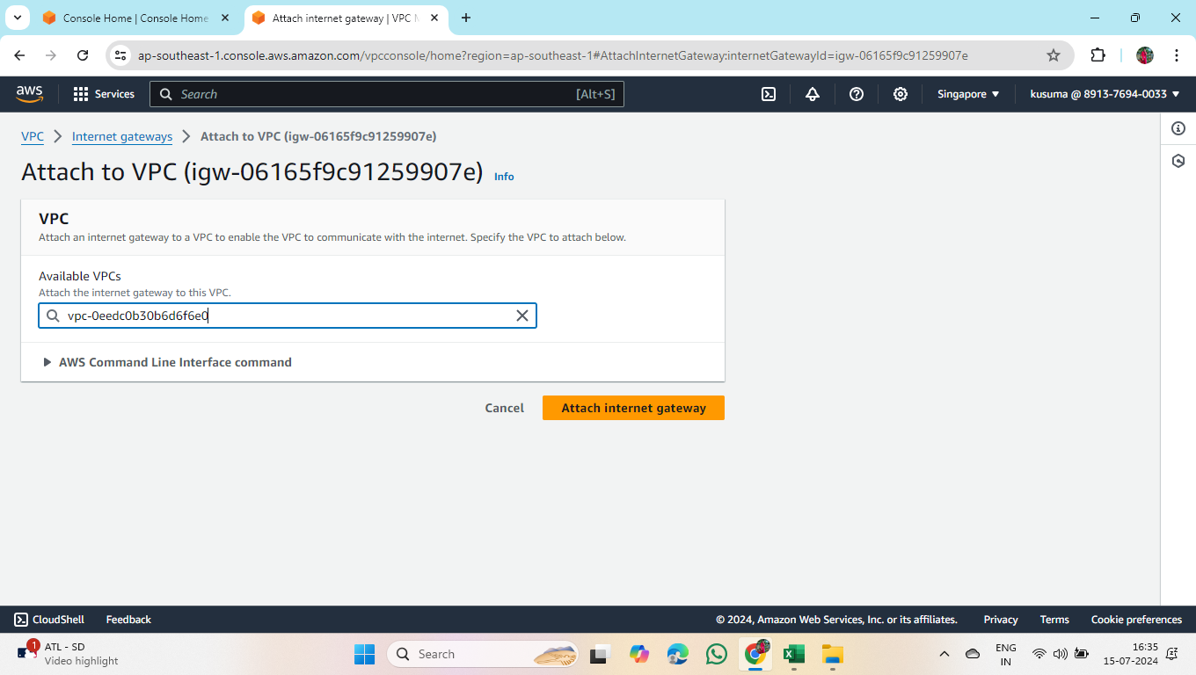

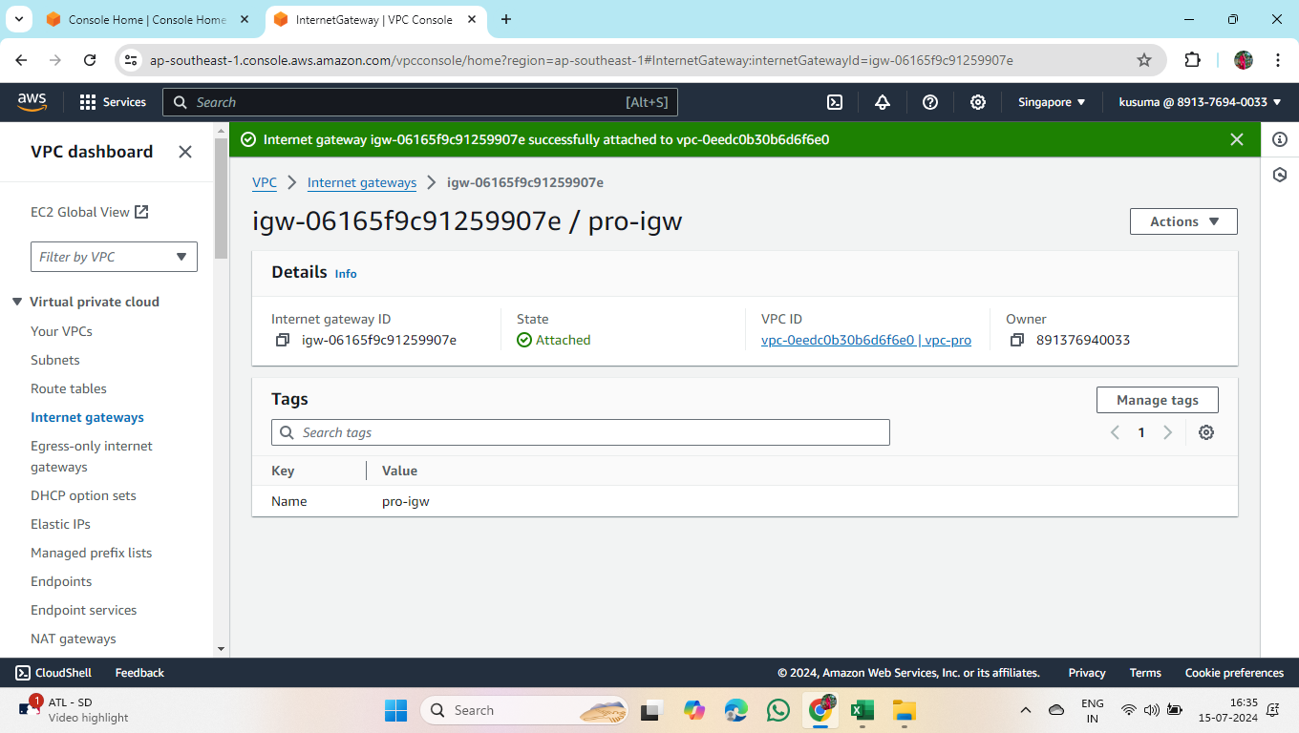

* Attach Internet Gateway to 2 public route tables.

6.Create NAT Gateway and attach it to public subnet.

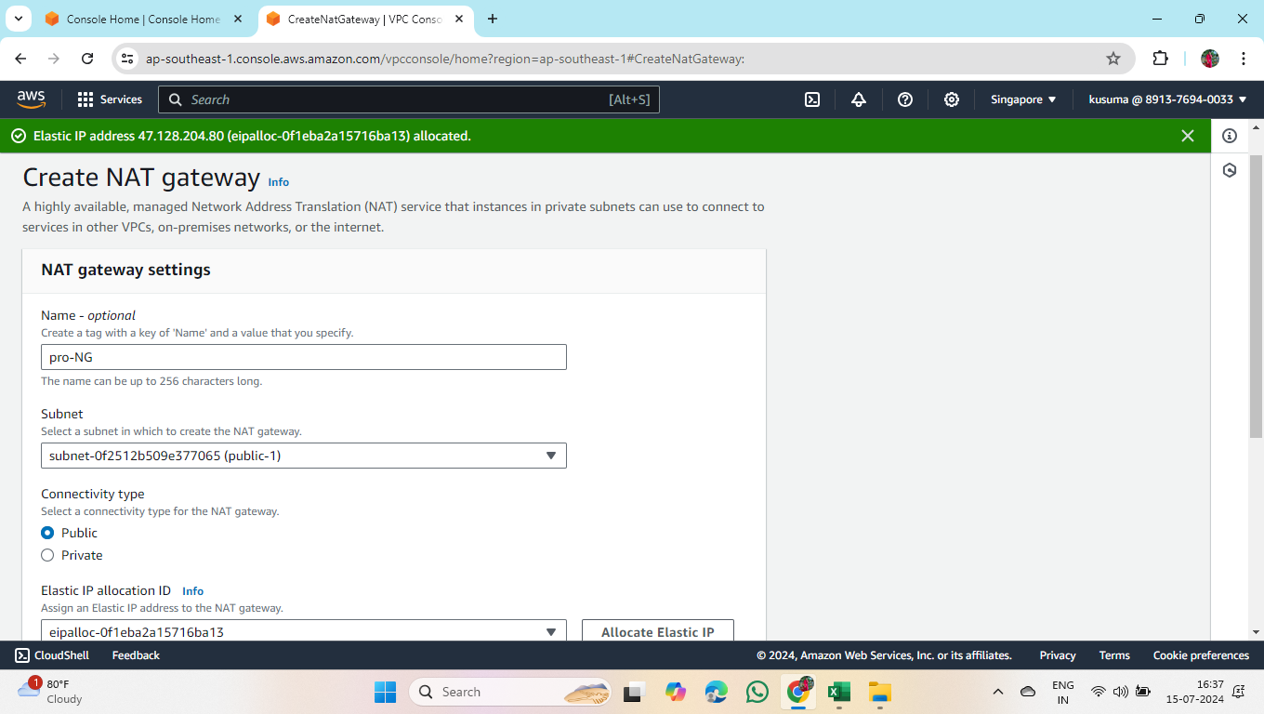

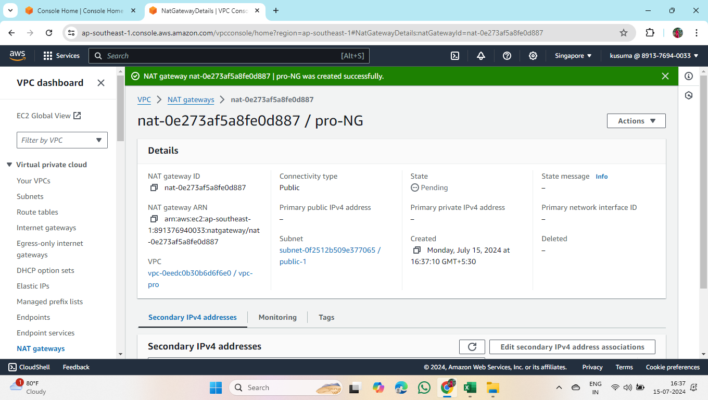

* After NAT Gateway is created, open private route table -> edit routes –> attach NAT Gateway.



7.Go to Subnets

* Click on subnets -> edit subnet settings -> enable auto-assign IPV4 address check box and save it for all the subnets.

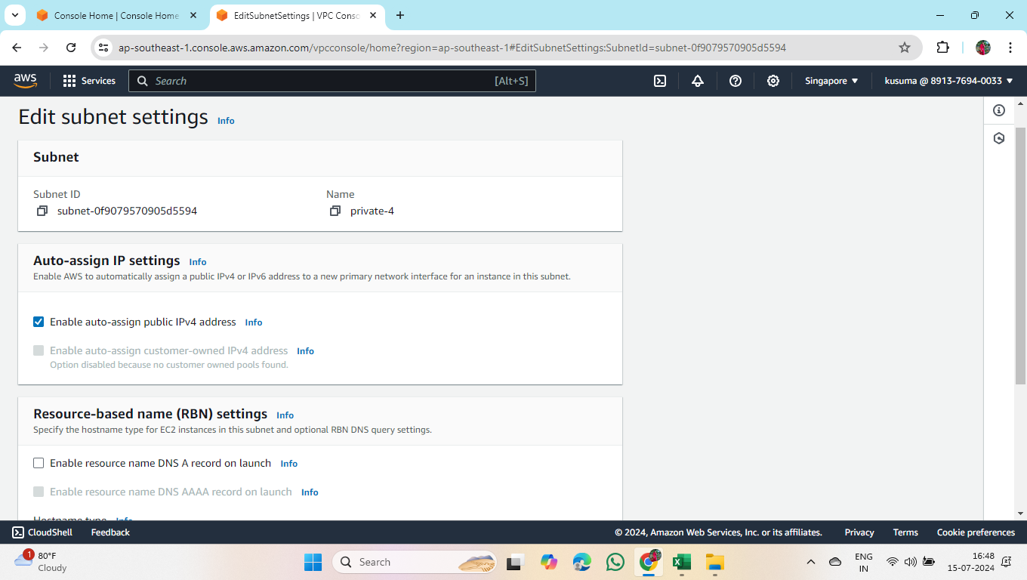

8.Create Security Group

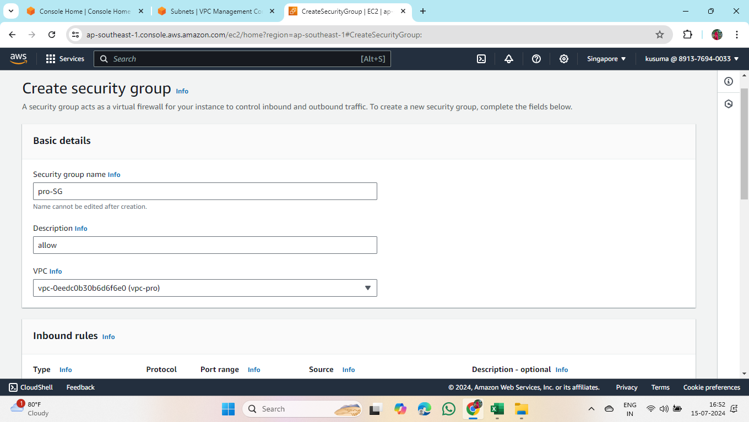

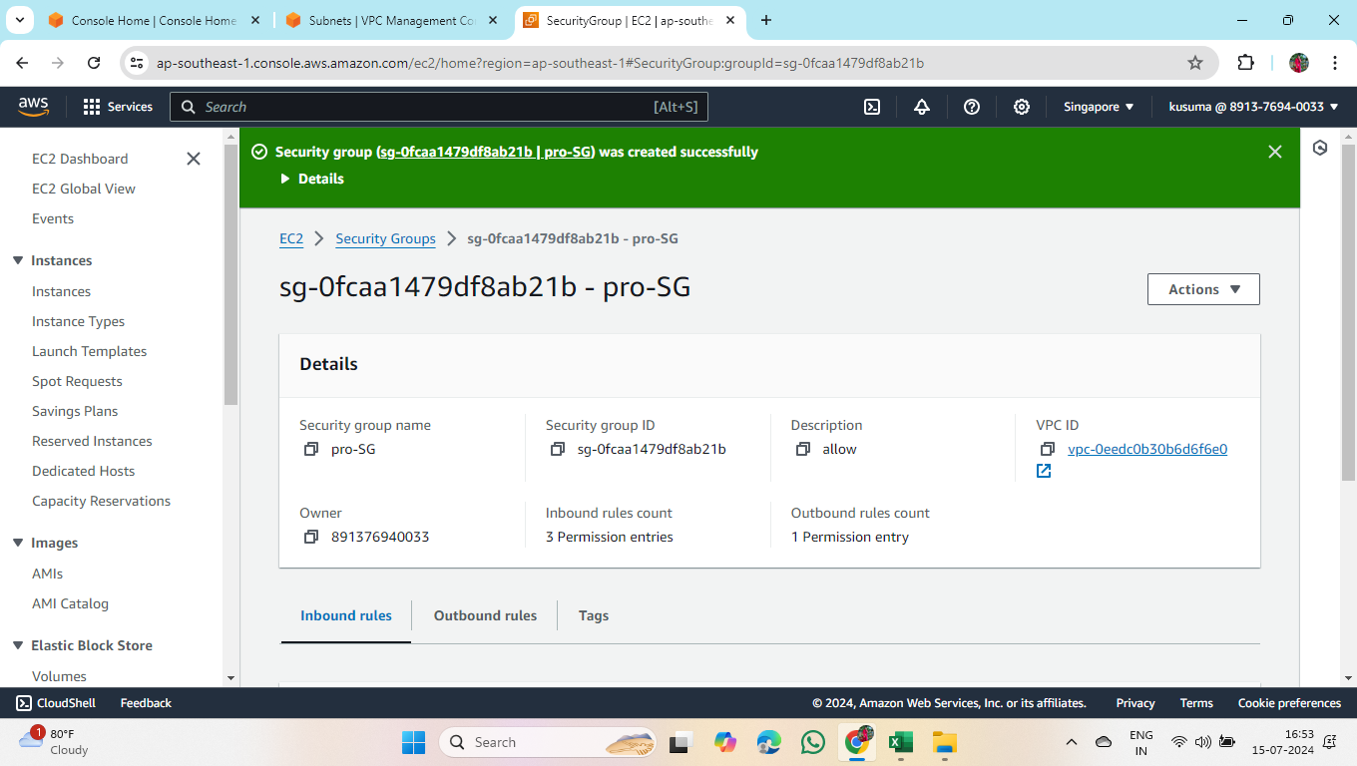

9. Create ec2 instances

* Create two instances (i.e public ec2 and private ec2)

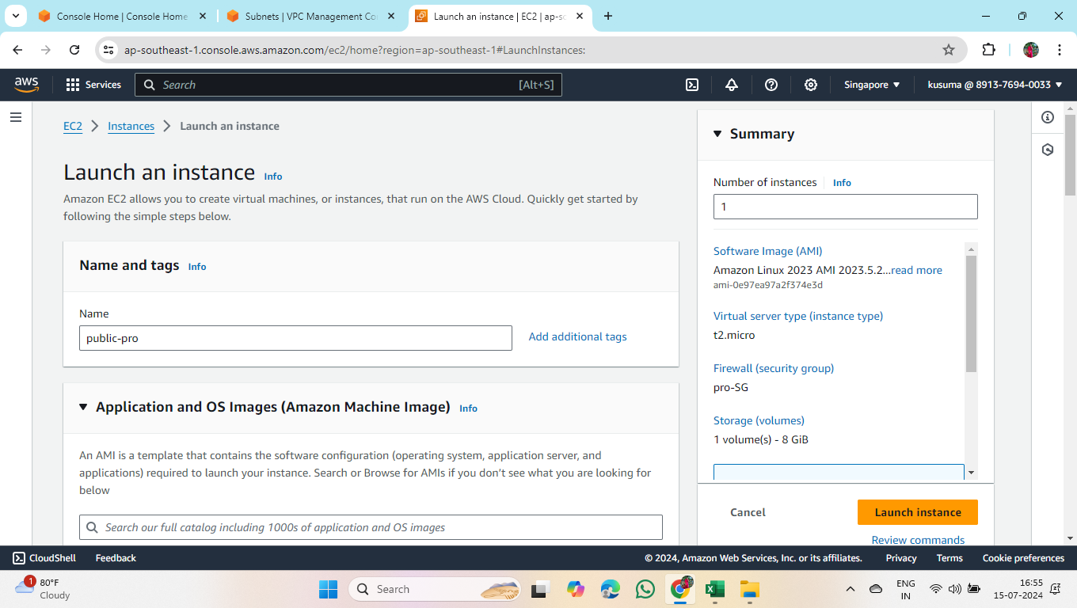

* Similarly for private instance also.

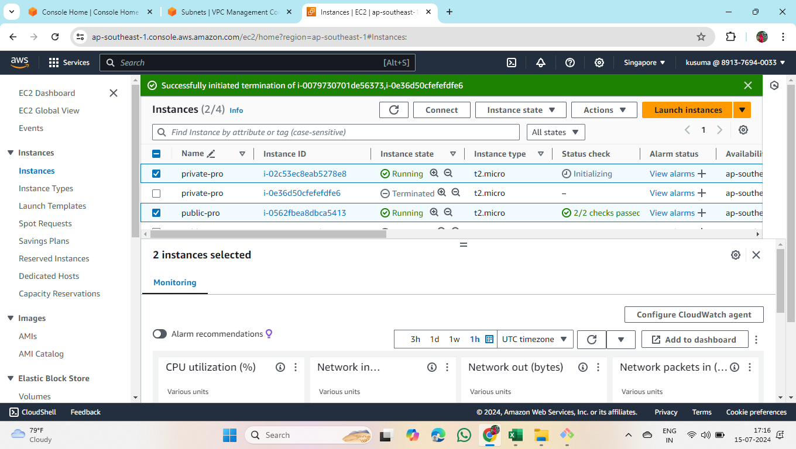

10.Connect EC2 to server

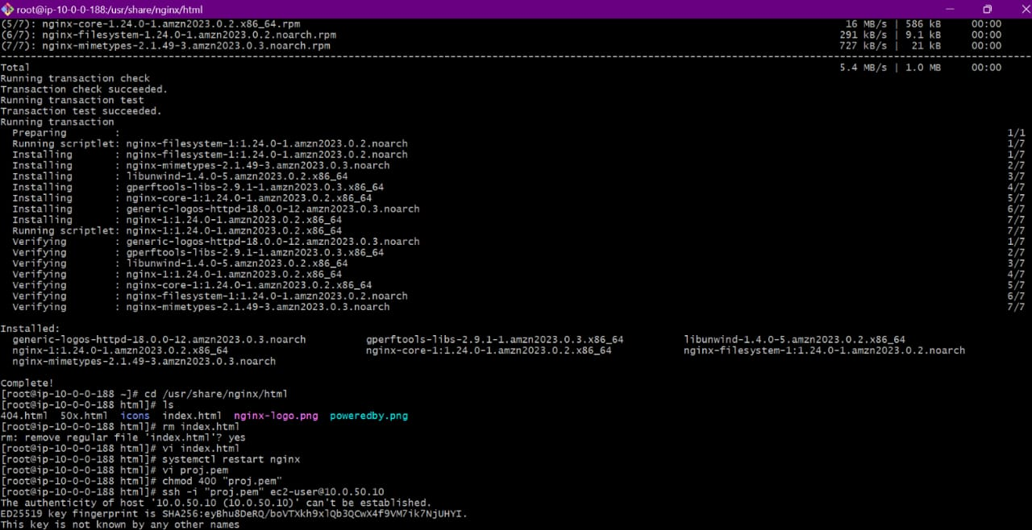

* This is how the webpage shows

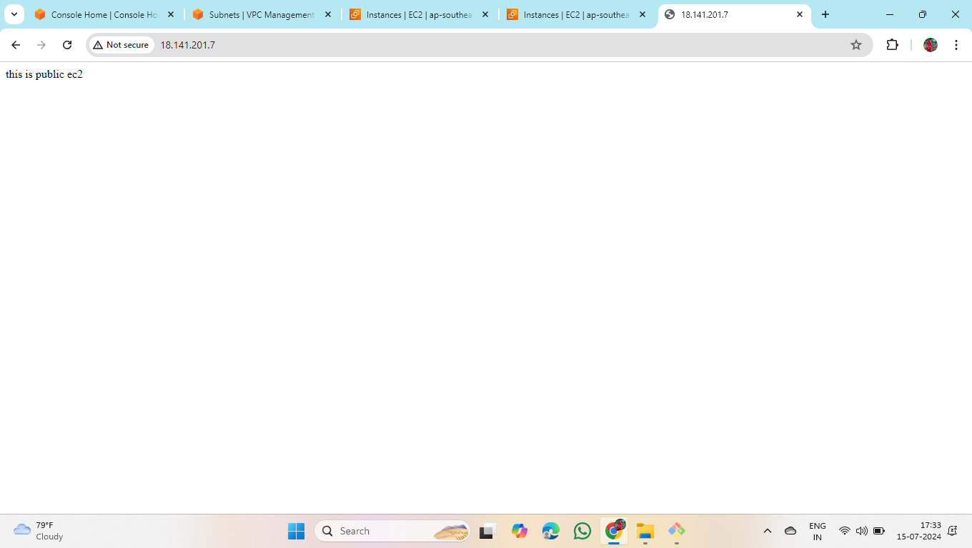

11. Create Load Balancer

* To create load balancer, first we have to create target group

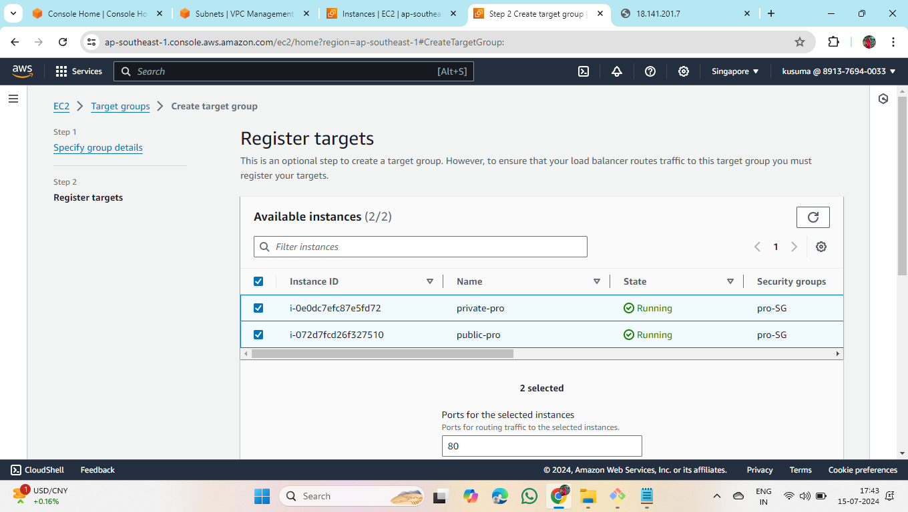

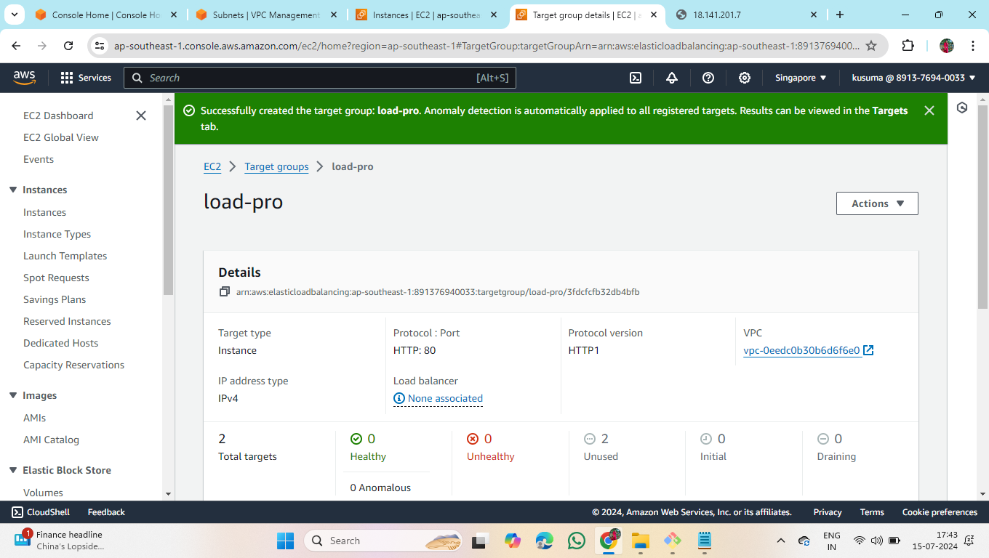

Create Load Balancer

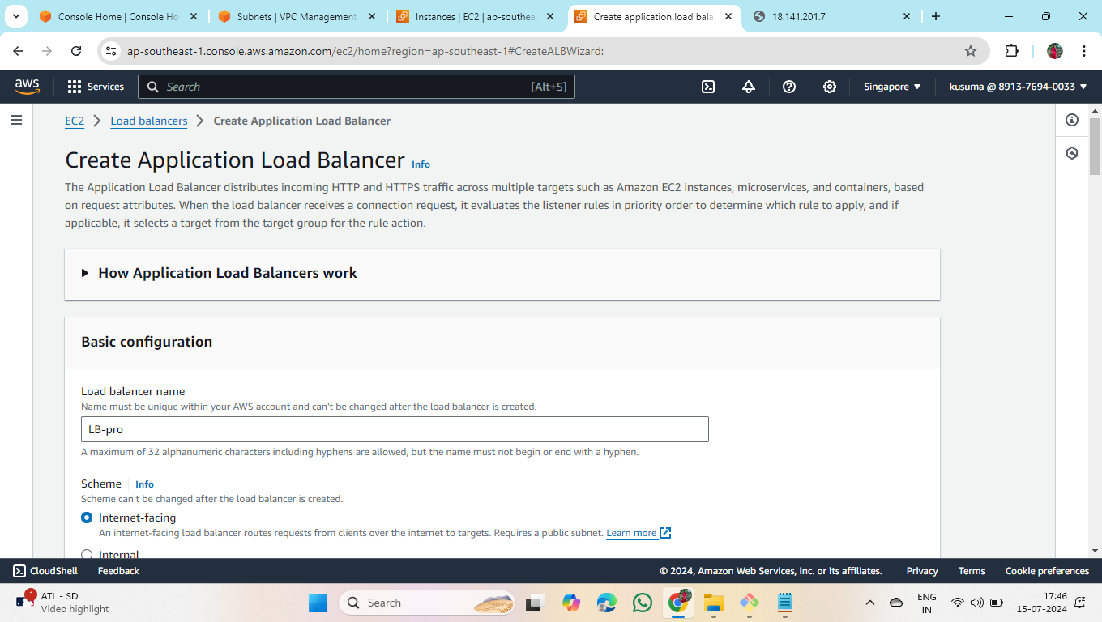

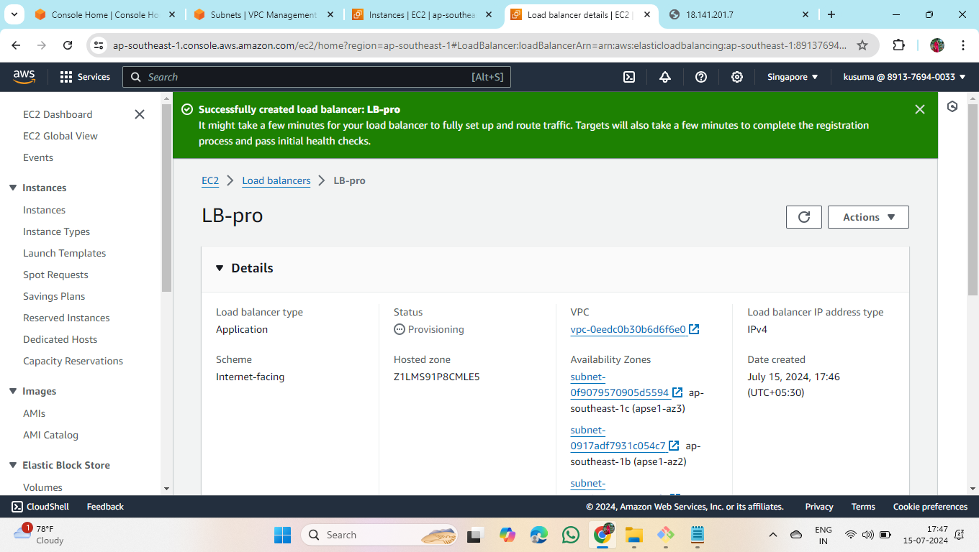

* Create another Load Balancer for private instance

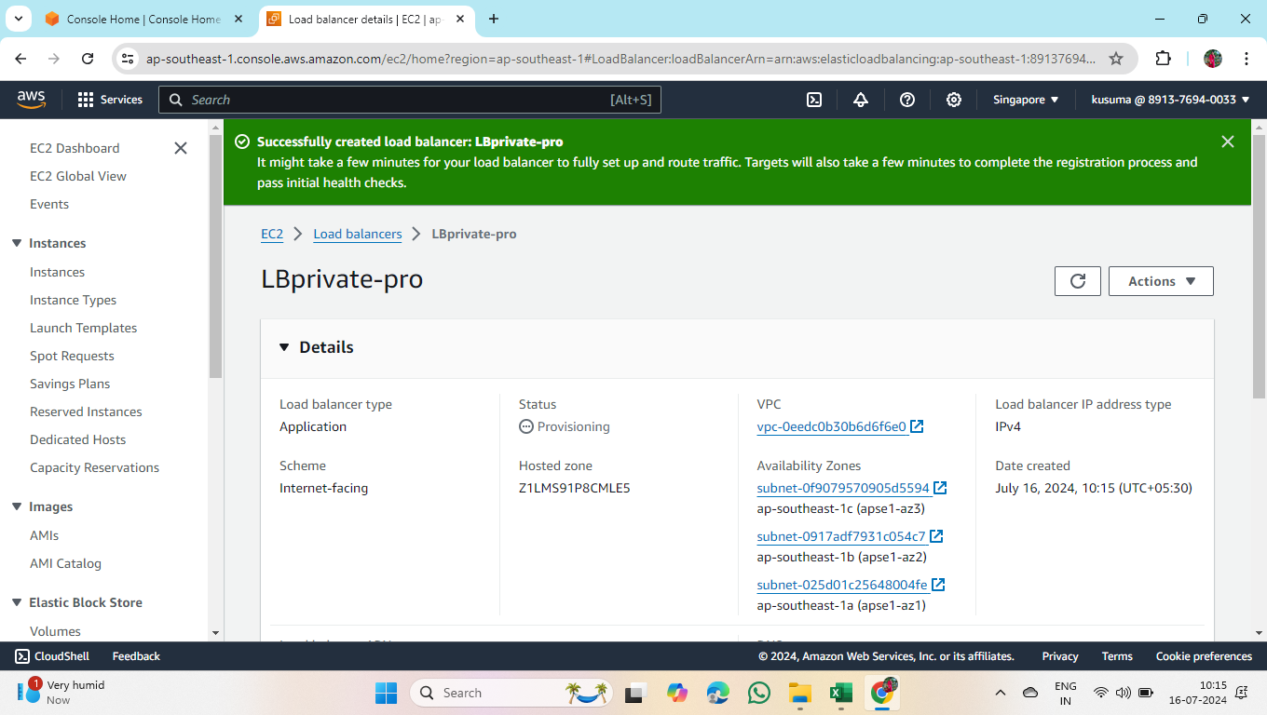

12. Create Auto Scaling group

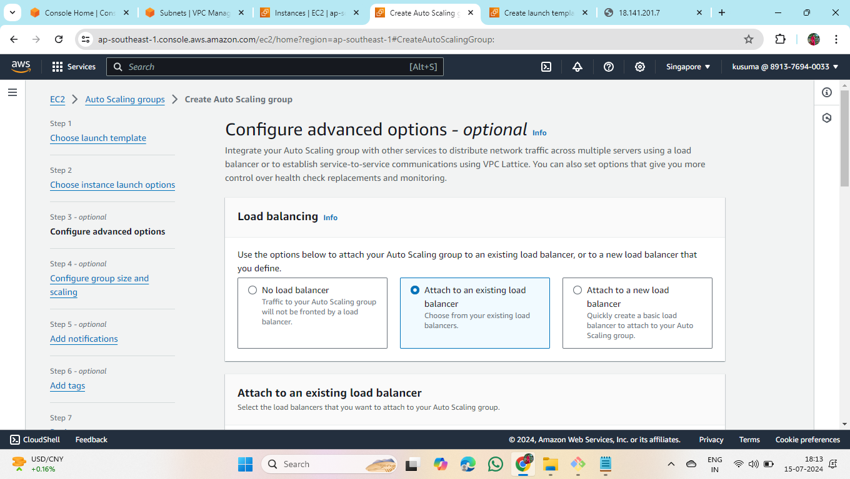

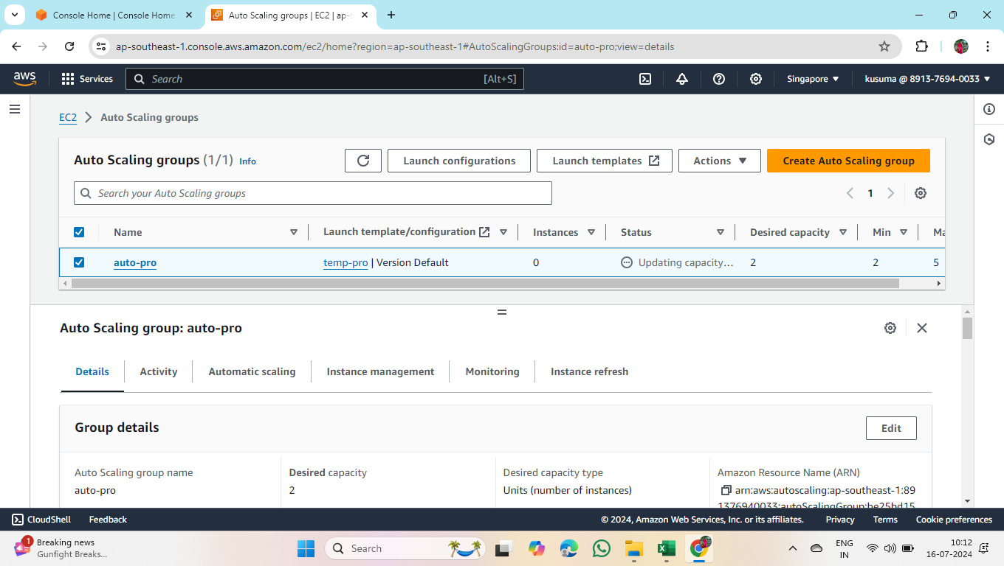

* Create 2 auto scaling groups one for public instance and one for private instance.

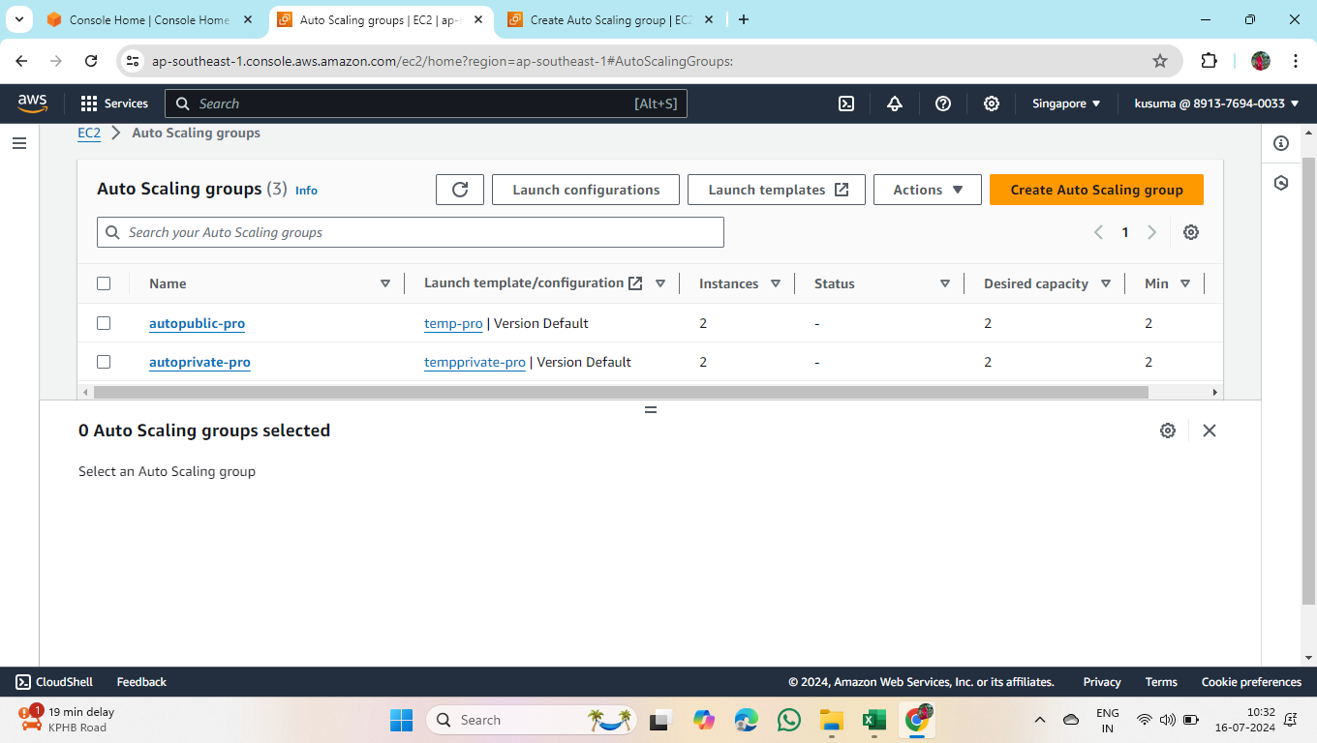

13. Create AMI separately for both public and private instances ->open the instance ->actions -> create image.

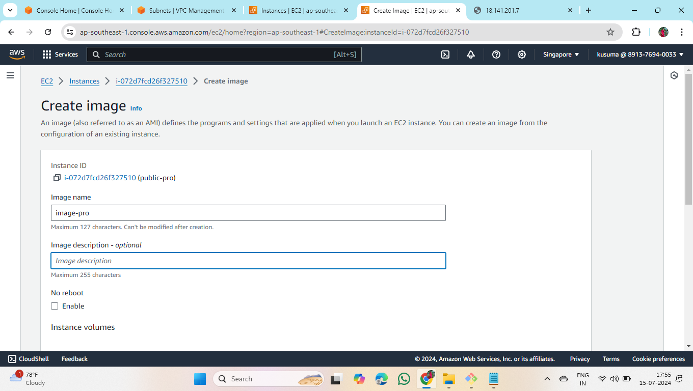

14.Create Launch Template for both public and private instance.

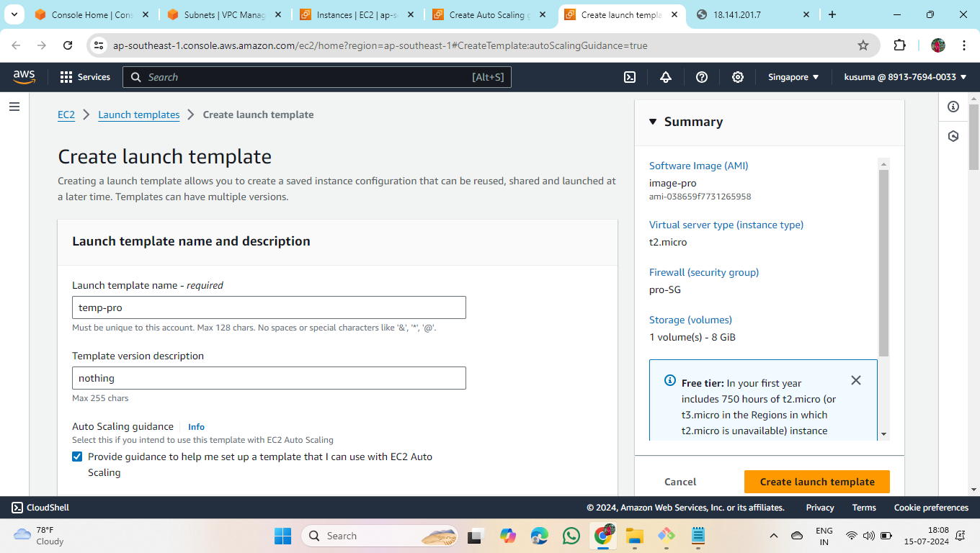

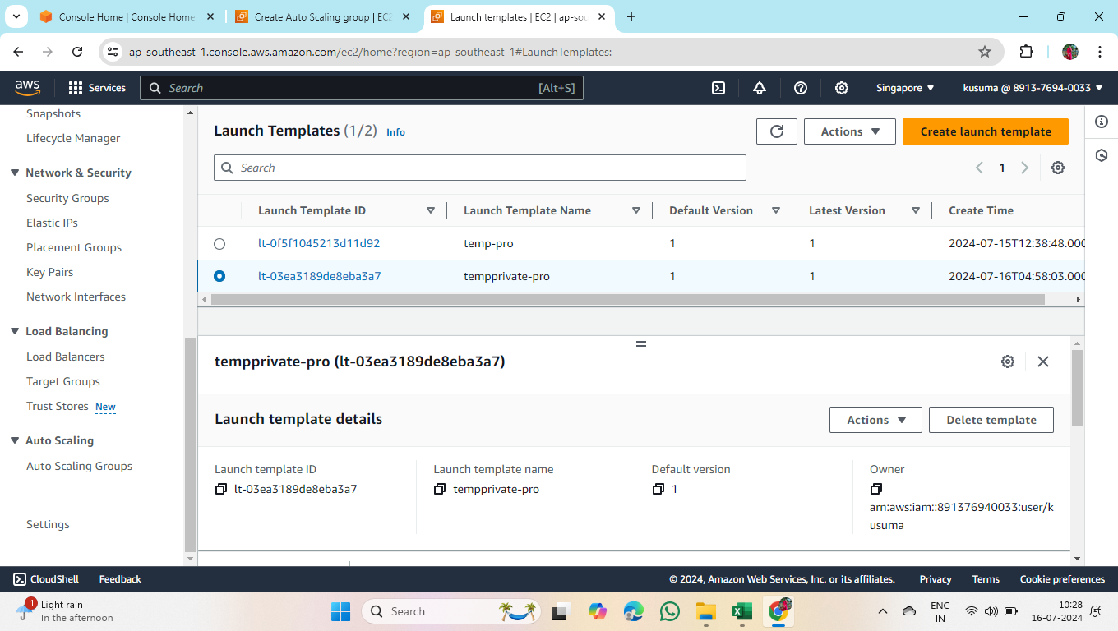

15.Create RDS

* First create database

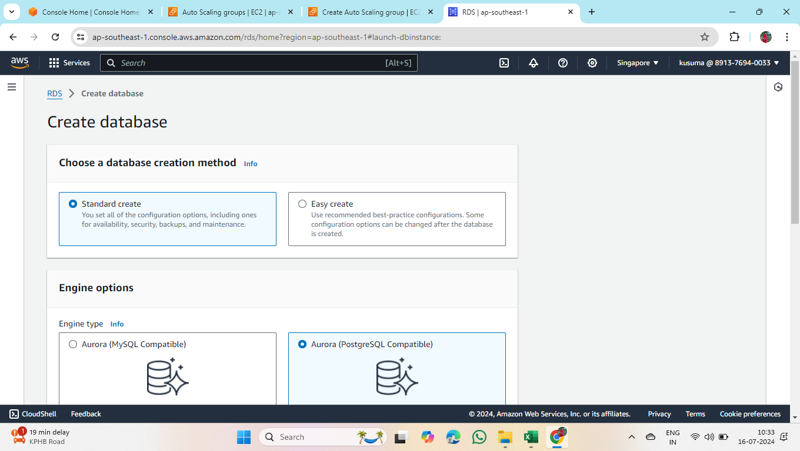

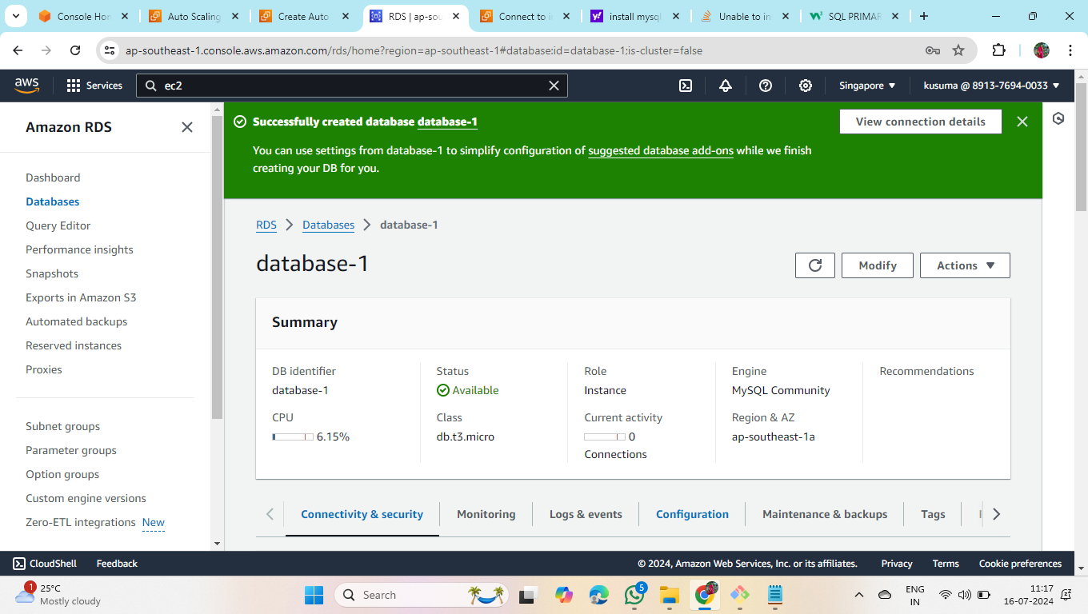

* Install Mysql

